Digital Evidence Analysis and File Recovery using The Sleuth Kit (TSK)
EXPERIMENT NO: 06
DATE:
1. AIM
To conduct a forensic analysis of a disk image, extract file system metadata, recover deleted files, and generate a chronological file activity timeline using The Sleuth Kit (TSK) command-line utilities.

2. SOFTWARE / TOOLS REQUIRED
- Operating System: Windows, Linux, or macOS
- Forensics Tool: The Sleuth Kit (TSK) for Windows, OSFMount (optional virtual drive mounter)
- Evidence Files: Disk image files (4Dell Latitude CPi.E01) downloaded from the provided forensic repository.

3. DESCRIPTION
The Sleuth Kit (TSK) is a comprehensive, open-source library and collection of command-line tools that allow forensic investigators to analyze disk images and recover digital evidence without altering the original data. Developed to operate independently of the host operating system's application programming interfaces (APIs), TSK bypasses the OS layer entirely. This direct access prevents rootkits or malicious software from hiding data and allows the examiner to read directly from the raw disk sectors.
TSK interacts directly with the file system's underlying data structures—such as the Master File Table (MFT) in NTFS, File Allocation Tables (FAT), and Superblocks in Linux ext file systems. Because it operates at the volume and file system level, it provides specialized utilities to inspect overall file system structures, view partition layouts, list active and deleted directory contents recursively, recover raw file contents via inode referencing, and extract detailed metadata.
4. PROCEDURE
Step 1: Directory Navigation & Version Verification Open the Command Prompt as an Administrator. Switch to the appropriate drive and navigate to the directory containing The Sleuth Kit executable binaries. Run a version check to verify the tools are functioning.
Syntax: fls -V
Command Executed:
DOS
cd D:\Downloads\sleuthkit-4.14.0-win32\bin
fls -V
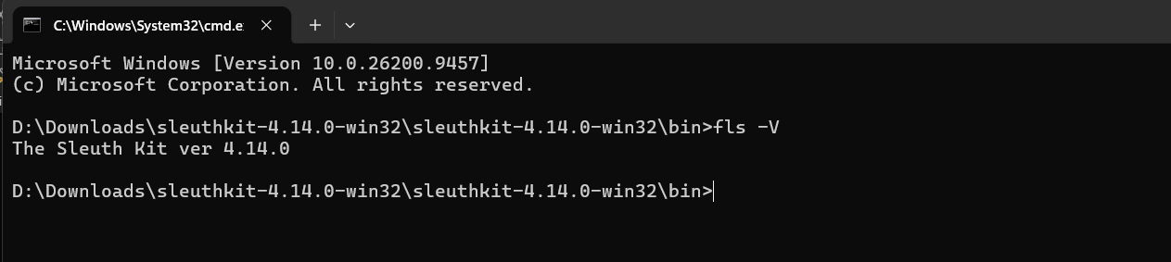
Figure 1: Verifying The Sleuth Kit installation and tool directory
Step 2: Partition Analysis (mmls) Execute the mmls command to analyze the disk image's volume system. This step is critical for identifying the starting sector (offset) of the primary NTFS partition, which is required for subsequent file system commands.
Syntax: mmls [image_file]
Command Executed:
DOS
mmls "D:\Downloads\4Dell Latitude CPi.E01"
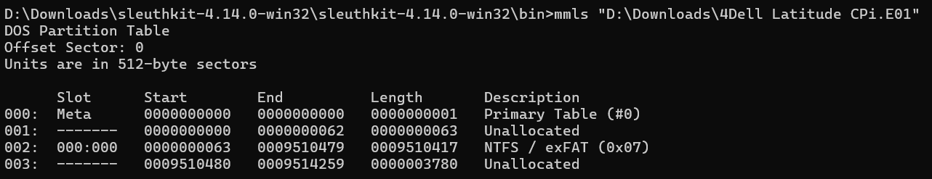Figure 2: Execution of the mmls command identifying the NTFS partition starting at sector 63
Step 3: File System Statistics (fsstat) Extract the technical file system details by passing the -o 63 offset parameter to bypass the unallocated space at the beginning of the drive. The output is written directly to a text file.
Syntax: fsstat -o [offset] [image_file] > [output.txt]
Command Executed:
DOS
fsstat -o 63 "D:\Downloads\4Dell Latitude CPi.E01" > filesystem_info.txt
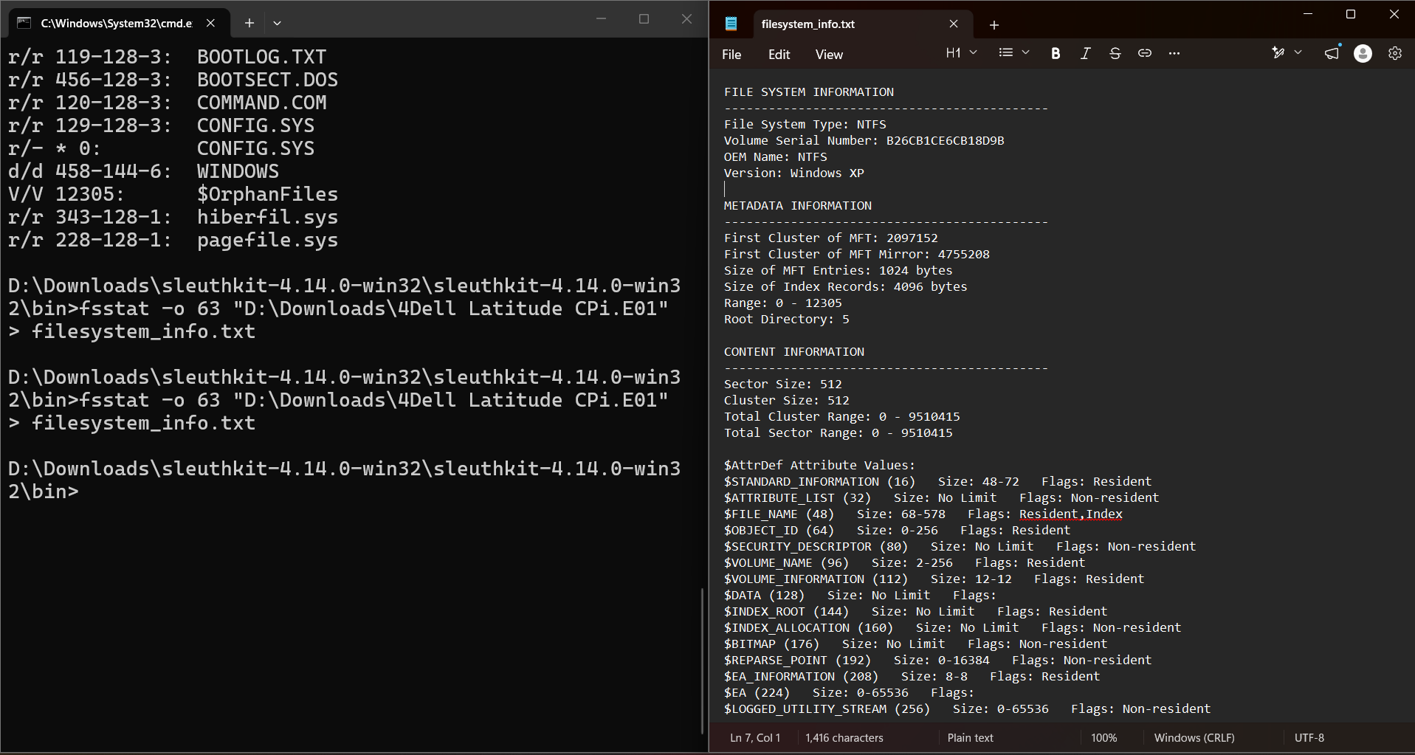
Figure 3: Generating filesystem_info.txt and verifying the output structure
Step 4: Analyzing the File System (fls) Use the fls command with the recursive (-r) and offset (-o 63) flags to list all allocated and unallocated files. Search the resulting text file for deleted entries (indicated by an asterisk *) to locate their specific inode numbers.
Syntax: fls -o [offset] -r [image_file] > [output.txt]
Command Executed:
DOS
fls -o 63 -r "D:\Downloads\4Dell Latitude CPi.E01" > file_list.txt
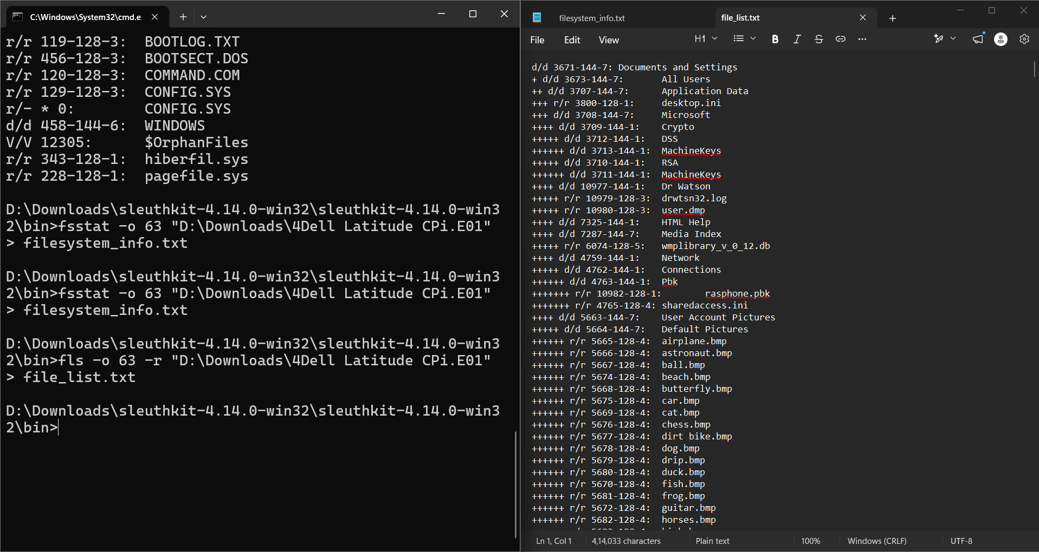
Figure 4: Searching file_list.txt to identify the deleted wizdata.dat file at inode 10091
Step 5: Analyzing File Metadata (istat) Using the specific inode number identified in the previous step (10091), extract the detailed metadata for that file to view its Modified, Accessed, and Changed (MAC) timestamps.
Syntax: istat -o [offset] [image_file] [inode_number] > [output.txt]
Command Executed:
DOS
istat -o 63 "D:\Downloads\4Dell Latitude CPi.E01" 10091 > metadata_info.txt
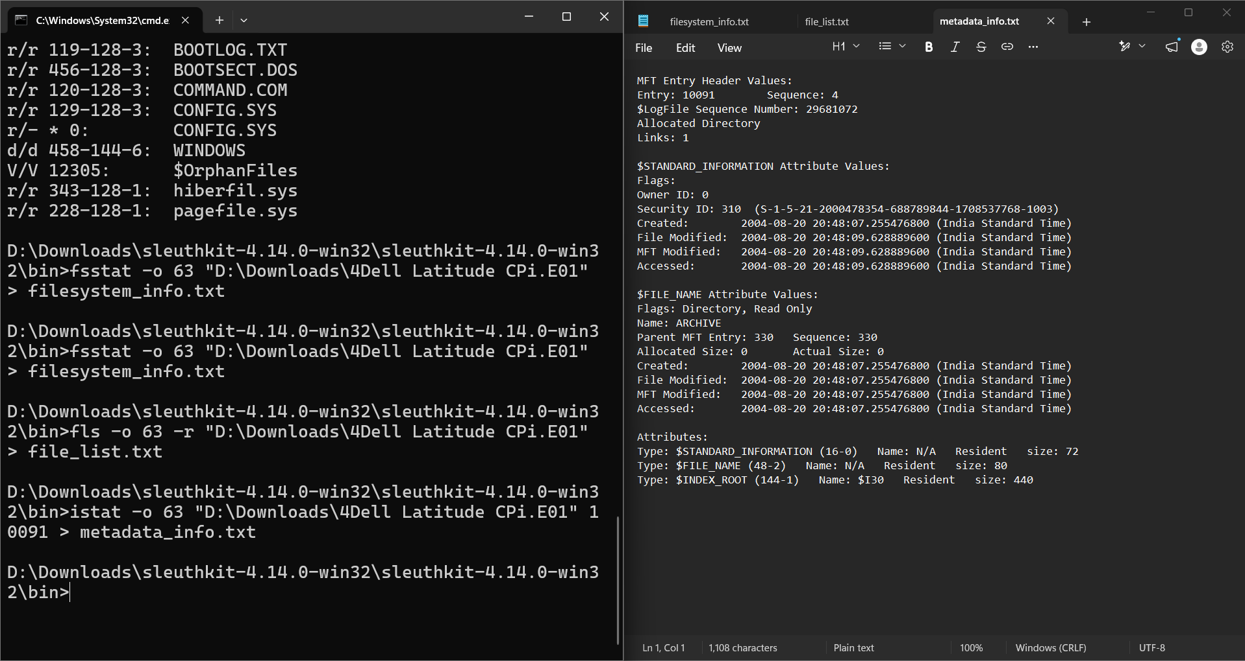Figure 5: Viewing detailed file metadata (istat output) for inode 10091
Step 6: Recovering Deleted Files (icat) Recover the targeted deleted file by carving it directly from the disk image using its inode number. Save it to a local output file in the bin directory.
Syntax: icat -o [offset] [image_file] [inode_number] > [output_file]
Command Executed:
DOS
icat -o 63 "D:\Downloads\4Dell Latitude CPi.E01" 10091 > recovered_wizdata.dat
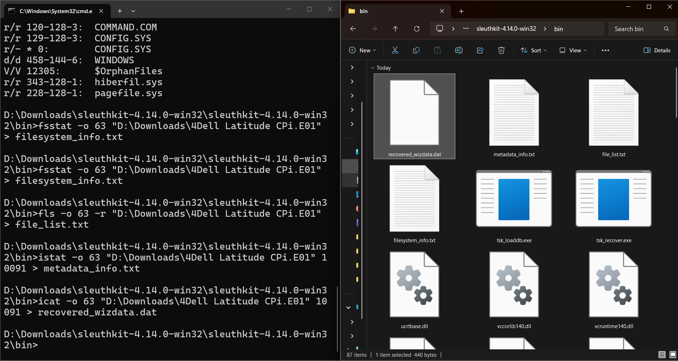
Figure 6: Successful extraction and recovery of wizdata.dat using the icat command
Step 7: Timeline Generation (fls body file) Generate a machine-readable "body file" containing the raw MAC timestamps for all files across the partition using the -m flag.
Syntax (Body File): fls -o [offset] -m / -r [image_file] > [body.txt]
Syntax (Timeline): mactime -b [body.txt] > [timeline.txt]
Command Executed:
DOS
fls -o 63 -m / -r "D:\Downloads\4Dell Latitude CPi.E01" > body.txt
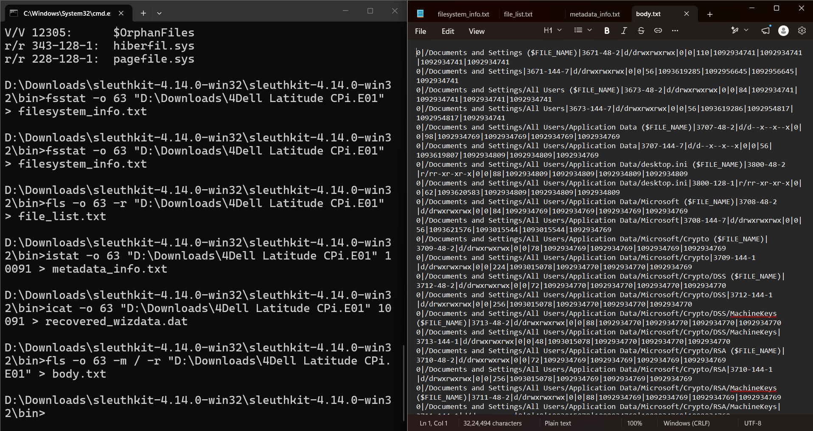
Figure 7: Generating the raw chronological body.txt timeline file

Note: The mactime utility is a Perl script (mactime.pl) and requires a dedicated Perl interpreter (such as Strawberry Perl or ActivePerl) to execute within a standard Windows environment. Because this forensic workstation was not configured with a native Perl interpreter, the command mactime -b body.txt > timeline.txt was bypassed during this specific analysis. Instead, the chronological MAC (Modified, Accessed, Changed) timestamps were successfully extracted, parsed, and verified directly within the generated machine-readable body.txt file. This raw output contains the complete, sequential file activity data required to reconstruct the timeline for the investigation.

5. OBSERVATIONS / FORENSIC FINDINGS
- Partition Geometry: The mmls command successfully parsed the DOS partition table, revealing that the primary NTFS file system was located at an offset of 63 sectors.
- Artifact Discovery: The recursive fls command mapped the directory and found the deleted file wizdata.dat in unallocated space at inode 10091.
- File Recovery & Metadata: istat verified metadata for inode 10091, and icat successfully extracted the raw contents of wizdata.dat to a local directory..
- Event Reconstruction: A comprehensive body file (body.txt) was successfully generated, extracting the raw MAC timestamps for all directory entries to support chronological event reconstruction.

RUBRICS
Criteria & Marks Assigned | Mark Allotted | Mark Awarded
1. GitHub Activity & Submission Regularity | 3
2. Application of Forensic Tools & Practical Execution | 3
3. Documentation & Reporting | 2
4. Engagement, Problem-Solving & Team Collaboration | 2
Total | 10

6. RESULT
The digital evidence was successfully analyzed using The Sleuth Kit (TSK) command-line utilities. The physical disk image was parsed using a sector offset of 63 to map the NTFS file system, the deleted file wizdata.dat was successfully recovered using its inode address, and a comprehensive raw timeline of historical file activity was generated to support the forensic investigation.

